

Emac top issue list

Revision History

Document Version | Date | Author | Comment
V 0.0.1 | 2012/03/04 | Namodtum.lu | Create

Content
1. OSI model 4
2. Smartbit performance issue 4
3. Rx discriptor list disoder 6

- OSI model
The Open Systems Interconnection (OSI) model (ISO/IEC 7498-1) is a product of the Open Systems Interconnection effort at the International Organization for Standardization. It is a prescription of characterizing and standardizing the functions of a communications system in terms of abstraction layers. Similar communication functions are grouped into logical layers. A layer serves the layer above it and is served by the layer below it.
For example, a layer that provides error-free communications across a network provides the path needed by applications above it, while it calls the next lower layer to send and receive packets that make up the contents of that path. Two instances at one layer are connected by a horizontal connection on that layer.
Mstar emac driver belongs to data link layer.
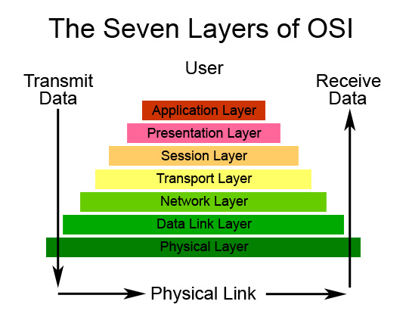
Fig. 1
- Smartbit performance issue (tx packet drop)
  - Use “cat/proc/net/snmp” to monitor packet propagate among network and transport layers as shown in Fig.2
    - The InType0 in IcmpMsg shows that kernel receive 2 ICMP packets from network layer to transport layer
    - The OutType8 in IcmpMsg shows that kernel sent 2 ICMP packets from transport layer to network layer
    - The OutRequests in Ip shows that kernel sent 2 packets from network layer to data link layer
    - The OutDiscards in Ip shows that kernel drop no packets in network layer
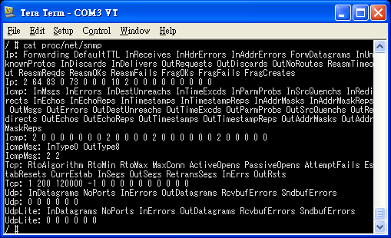
Fig. 2

  - Use “ifconfig” to monitor packets in and out Mstar emac hardware as shown in Fig. 3.
    - In this case, mstar emac receive 45 packets from physical layer, and sent 3 packets out.
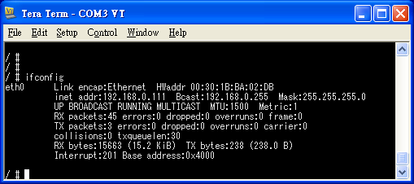
Fig. 3
  - Syndrome: The number of TX packet showed in ifconfig is less than the value of InType0 in IcmpMsg showed in snmp, which means that the packets lose between transport layer and data link layer.
  - Cause: Because “icmp_xmit_lock” in “net/ipv4/icmp.c” use “spin_trylock”, TX packet will lost when “spin_trylock” return fail.
  - Patch@CL#1271715: The patch replaces “spin_trylock” with “spin_lock” to make sure packet free from lost.

- RX descriptor list disorder
  - Syndrome: The issue can be triggered by the means of playing on-line video via HBBTV as well as using remote controller to manipulate menu. After 5 minutes, the Ethernet will be extremely unstable.
  - Cause: The cause is that Mstar emac hardware does not access the RX descriptor list orderly as shown as Fig. 4.
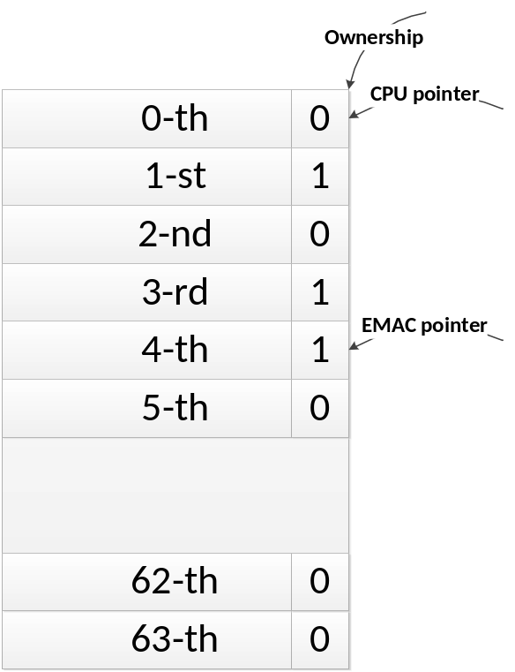
Fig. 4

  - Patch@CL#454904: Enforce CPU traverse the next every entry in the list as soon as it encounters the entry, which the ownership is zero. When there is no entry with ownership 1 on the next all entries, CPU returns from RX function.

